Q1)

#include <iostream>

#include <string>

#include <algorithm>

using namespace std;

void reverseWords(string& sentence) {

reverse(sentence.begin(), sentence.end());

size_t start = 0;

size_t end = sentence.find(' ');

while (end != string::npos) {

reverse(sentence.begin() + start, sentence.begin() + end);

start = end + 1;

end = sentence.find(' ', start);

}

reverse(sentence.begin() + start, sentence.end());

}

int main() {

string sentence;

cout << "Enter a sentence: ";

getline(cin, sentence);

reverseWords(sentence);

cout << "Reversed sentence: " << sentence << endl;

return 0;

}

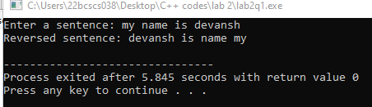

Q2)

#include <iostream>

using namespace std;

const int MAX_SIZE = 100;

float calculateAverage(int numbers[], int size) {

float sum = 0;

for (int i = 0; i < size; i++) {

sum += numbers[i];

}

return sum / size;

}

int main() {

int numbers[MAX_SIZE];

int size;

cout << "Enter the number of elements (up to " << MAX_SIZE << "): ";

cin >> size;

cout << "Enter the numbers: ";

for (int i = 0; i < size; i++) {

cin >> numbers[i];

}

float average = calculateAverage(numbers, size);

cout << "Average: " << average << endl;

return 0;

}

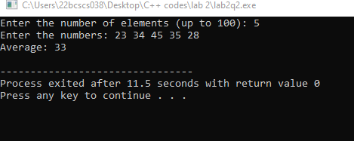

Q3)

#include <iostream>

using namespace std;

bool isAlphabetOrNumber(char ch) {

if ((ch >= 'a' && ch <= 'z') || (ch >= 'A' && ch <= 'Z') || (ch >= '0' && ch <= '9')) {

return true;

} else {

return false;

}

}

int main() {

char ch;

cout << "Enter a character: ";

cin >> ch;

if (isAlphabetOrNumber(ch)) {

cout << ch << " is an alphabet or number." << endl;

} else {

cout << ch << " is not an alphabet or number." << endl;

}

return 0;

}

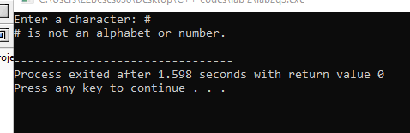

Q4)

#include <iostream>

using namespace std;

const int MAX_SIZE = 100;

int findLargestElement(int numbers[], int size) {

int largest = numbers[0];

for (int i = 1; i < size; i++) {

if (numbers[i] > largest) {

largest = numbers[i];

}

}

return largest;

}

int main() {

int numbers[MAX_SIZE];

int size;

cout << "Enter the number of elements (up to " << MAX_SIZE << "): ";

cin >> size;

cout << "Enter the numbers: ";

for (int i = 0; i < size; i++) {

cin >> numbers[i];

}

int largest = findLargestElement(numbers, size);

cout << "Largest element: " << largest << endl;

return 0;

}

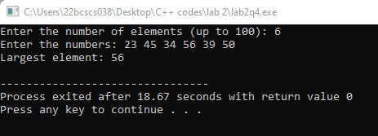

Q5)

#include <iostream>

using namespace std;

int main() {

float num1, num2;

char operation;

cout << "Enter first number: ";

cin >> num1;

cout << "Enter an operator (+, -, *, /): ";

cin >> operation;

cout << "Enter second number: ";

cin >> num2;

switch (operation) {

case '+':

cout << "Result: " << num1 + num2 << endl;

break;

case '-':

cout << "Result: " << num1 - num2 << endl;

break;

case '*':

cout << "Result: " << num1 * num2 << endl;

break;

case '/':

if (num2 != 0) {

cout << "Result: " << num1 / num2 << endl;

} else {

cout << "Error: Division by zero is not allowed." << endl;

}

break;

default:

cout << "Error: Invalid operator." << endl;

break;

}

return 0;

}

